**1 INTRODUCTION**

* 1. **OVERVIEW:**

An android Application for keeping up with the latest MailApp. The app's main feature is displaying a list of send mails, and to receive mails from others. Users can register their details and login into the application .The app uses the Jetpack Compose UI toolkit to build the UI and it uses the coil library to load images. The app fetches data from a remote server using Retrofit library and demonstrates how to use the Jetpack Compose UI toolkit for Android development.it is very useful for all the people who can access this app. At any time user can access this app and go through all the mail id to sent body and subject of the mail. **The "Online Adaptive Mail App" has been developed to override the problems prevailing in the practicing manual system. This software is supported to eliminate and in some cases reduce the hardships faced by this existing system. Moreover this system is designed for the particular need of the company to carry out operations in a smooth and effective manner.**

**The application is reduced as much as possible to avoid errors while entering the data. It also provides error message while entering invalid data. No formal knowledge is needed for the user to use this system. Thus by this all it proves it is user-friendly. Online Adaptive Mail App, as described above, can lead to error free, secure, reliable and fast management system. It can assist the user to concentrate on their other activities rather to concentrate on the record keeping. Thus it will help organization in better utilization of resources.**

**This is designed to assist in strategic planning, and will help you ensure that your organization is equipped with the right level of information and details for your future goals. Also, for those busy executive who are always on the go, our systems come with remote access features, which will allow you to manage your workforce anytime, at all times. These systems will ultimately allow you to better manage resources.**

* 1. **PURPOSE:**

The main objective of the Project on Online Adaptive Mail is to manage the details of related to sender and receiver. It manages all the information about the content of the mail. The project is totally built at administrative end and thus only the administrator is guaranteed the access. The purpose of the project is to build an application program to reduce the manual work for managing the sending Quicker mails with the App.

**2.PROBLEM DEFINITION AND DESIGN THINKING:**

**2.1 EMPATHY MAP:**

Empathy map shows the users,thinking,feelings,about the problem.

This map also gives information about users expectation.

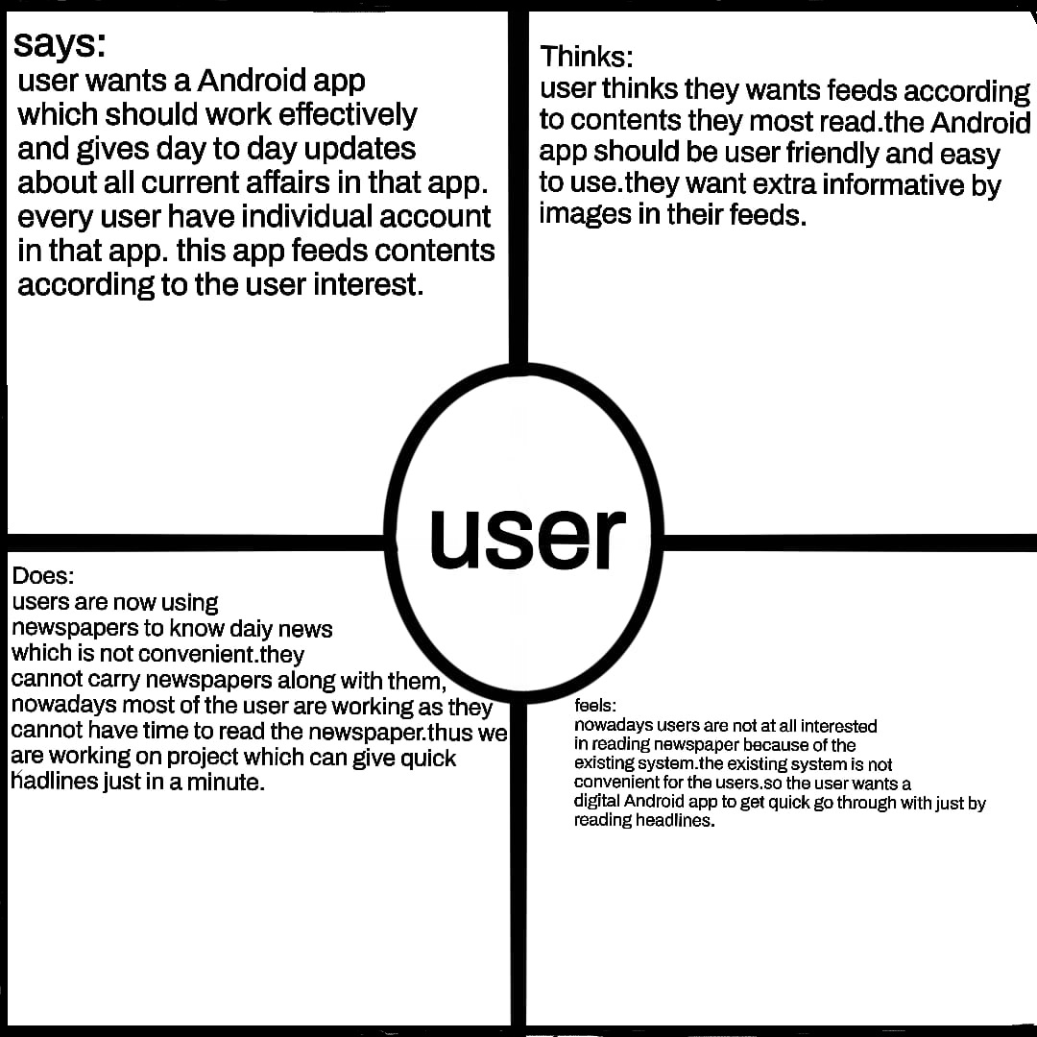

**3.RESULT**

**Register Page:**

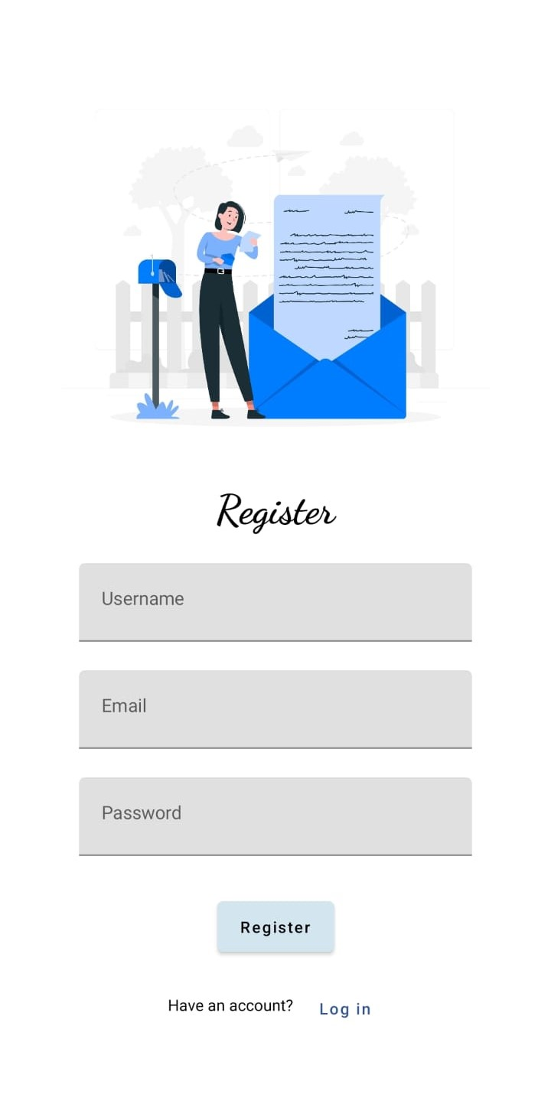

**Login Page:**

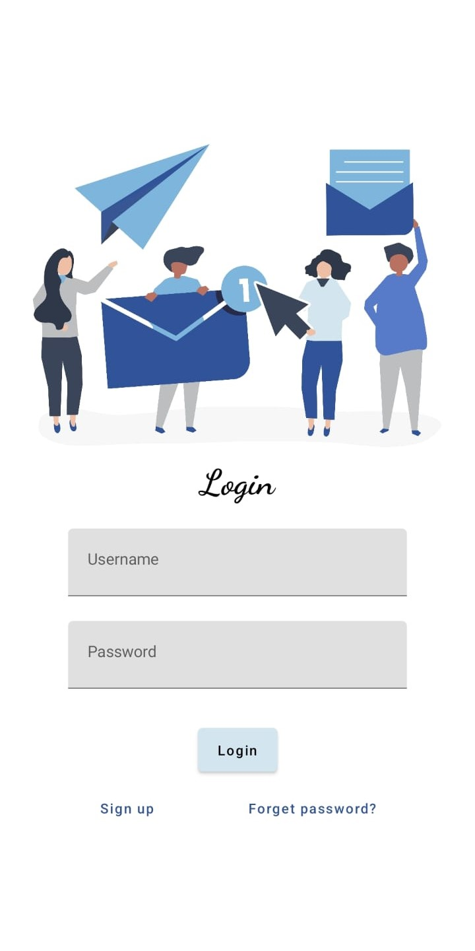

**Home Screen:**

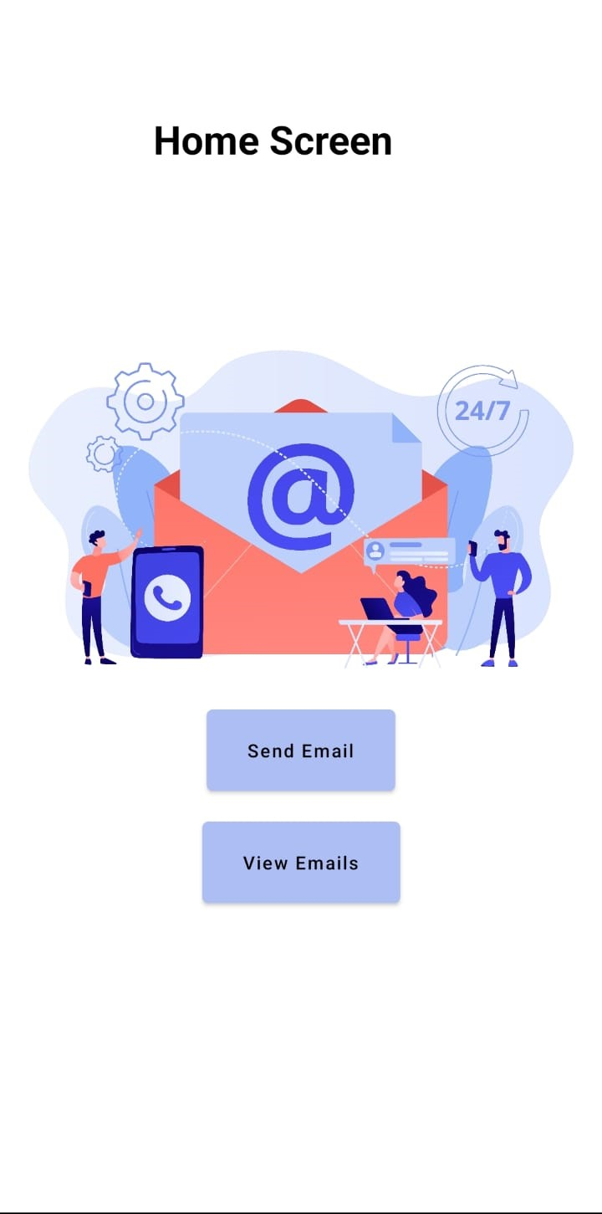

**SendMail Page:**

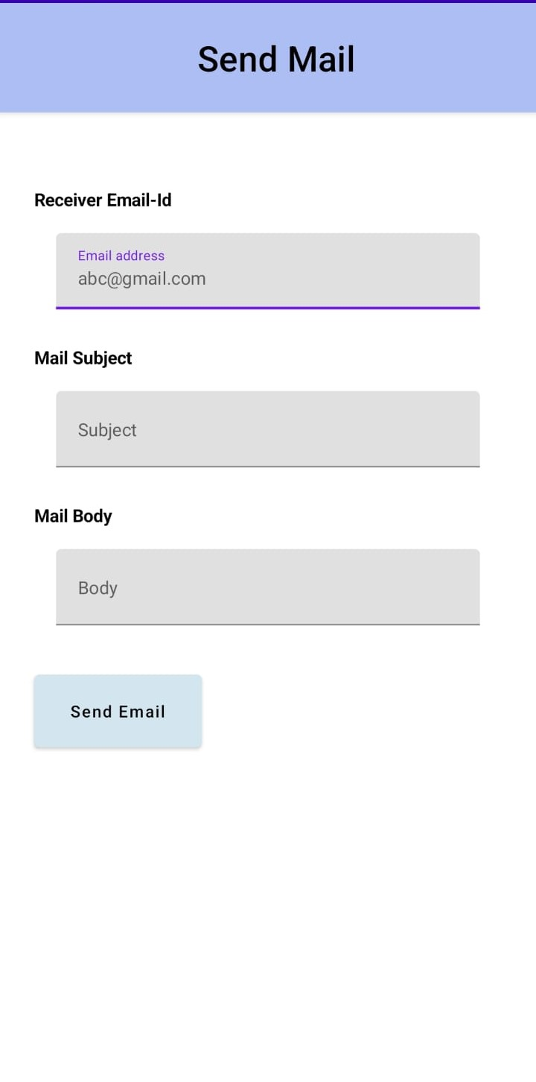

**ViewMail Page:**

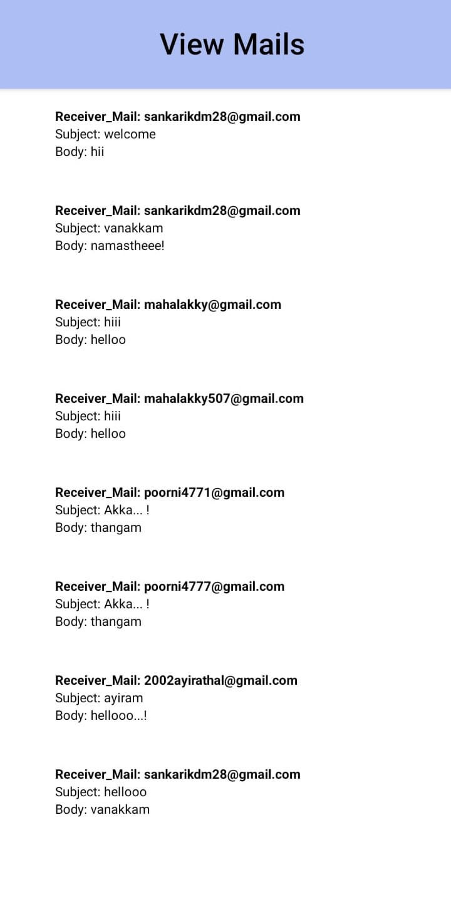

**4.ADVANTAGES AND DISADVANTAGES:**

**ADVANTAGES:**

The aim of proposed system is to develop a system of improved facilities. The

proposed system can overcome all the limitations of the existing system. The system

provides proper security and reduces the manual work.

⚫ Security of data.

Ensure data accuracy's.

⚫ Proper control of the higher officials.

• Minimize manual data entry.

⚫ Minimum time needed for the various processing

• Greater efficiency.

• Better service.

• User friendliness and interactive.

Minimum time required.

**DISADVANTAGES:**

* Require data/WIFI to get online.
* Companies not making as much money due to free reading for audiences.
* News spreads quicker online - people find out news before they should

Lose money - can't get people to pay for digital.

* Older audiences may not access digital platforms
* Costly to maintain
* Errors stay online FOREVER
* Fake News!

**5.APPLICATIONS:**

study sites offer the information to the public, political,

social, sports, health, entertainment etc.

2. Instant & latest study related news from all over the world.

3. Easier accessibility.

4. Fastest and Latest news updates as per the interest.

5. Live coverage of Events, Cricket matches and other sports

etc.

6. A reader can easily give his/her comments on any issue.

7. Breaking News can update Minute-to-minute.

8. Pictures of specials news events.

9.Advertiser gets the details of people who read their study related ad,

this facility cannot offer by Print or Electronic media.

**6.CONCLUSION**:

This android app will surely useful for all the users by giving them day to day updates via this application. our project work, an attempt has been made to develop a study News or information based web site. We develop this project that helps the people and make them aware so that they can know any news. To establish this website we use various methodologies. To develop this project we have faced many problem but we hardly tried to develop this project. Our supervisor helps us by giving his valuable opinion, decision and time.

**7.FUTURE SCOPE:**

The future scope of our project is valuable. Our project time duration was only one years. In this time interval we developed our project. It was very difficult to complete project within this time duration. In future if we get chance we will develop this website for large volume. As for other future developments, the following can be done:

* We will manage study news reporting system.
* We can make video conferencing system,
* We update our database.
* Sensibility level could add be added.
* We can go live.

**8.Appendix:**

**Build Gradle:**

|  |
| --- |
| plugins { |
|  | id 'com.android.application' |
|  | id 'org.jetbrains.kotlin.android' |
|  | } |
|  |  |
|  | android { |
|  | namespace 'com.example.emailapplication' |
|  | compileSdk 33 |
|  |  |
|  | defaultConfig { |
|  | applicationId "com.example.emailapplication" |
|  | minSdk 21 |
|  | targetSdk 33 |
|  | versionCode 1 |
|  | versionName "1.0" |
|  |  |
|  | testInstrumentationRunner "androidx.test.runner.AndroidJUnitRunner" |
|  | vectorDrawables { |
|  | useSupportLibrary true |
|  | } |
|  | } |
|  |  |
|  | buildTypes { |
|  | release { |
|  | minifyEnabled false |
|  | proguardFiles getDefaultProguardFile('proguard-android-optimize.txt'), 'proguard-rules.pro' |
|  | } |
|  | } |
|  | compileOptions { |
|  | sourceCompatibility JavaVersion.VERSION_1_8 |
|  | targetCompatibility JavaVersion.VERSION_1_8 |
|  | } |
|  | kotlinOptions { |
|  | jvmTarget = '1.8' |
|  | } |
|  | buildFeatures { |
|  | compose true |
|  | } |
|  | composeOptions { |
|  | kotlinCompilerExtensionVersion '1.2.0' |
|  | } |
|  | packagingOptions { |
|  | resources { |
|  | excludes += '/META-INF/{AL2.0,LGPL2.1}' |
|  | } |
|  | } |
|  | } |
|  |  |
|  | dependencies { |
|  |  |
|  | implementation 'androidx.core:core-ktx:1.7.0' |
|  | implementation 'androidx.lifecycle:lifecycle-runtime-ktx:2.3.1' |
|  | implementation 'androidx.activity:activity-compose:1.3.1' |
|  | implementation "androidx.compose.ui:ui:$compose_ui_version" |
|  | implementation "androidx.compose.ui:ui-tooling-preview:$compose_ui_version" |
|  | implementation 'androidx.compose.material:material:1.2.0' |
|  | implementation 'androidx.room:room-common:2.5.0' |
|  | implementation 'androidx.room:room-ktx:2.5.0' |
|  | testImplementation 'junit:junit:4.13.2' |
|  | androidTestImplementation 'androidx.test.ext:junit:1.1.5' |
|  | androidTestImplementation 'androidx.test.espresso:espresso-core:3.5.1' |
|  | androidTestImplementation "androidx.compose.ui:ui-test-junit4:$compose_ui_version" |
|  | debugImplementation "androidx.compose.ui:ui-tooling:$compose_ui_version" |
|  | debugImplementation "androidx.compose.ui:ui-test-manifest:$compose_ui_version" |
|  | } |

**MainActivity.kt:**

|  |  |
| --- | --- |
|  | import android.content.Context |
|  | import android.content.Intent |
|  | import android.os.Bundle |
|  | import androidx.activity.ComponentActivity |
|  | import androidx.activity.compose.setContent |
|  | import androidx.compose.foundation.Image |
|  | import androidx.compose.foundation.background |
|  | import androidx.compose.foundation.layout.* |
|  | import androidx.compose.material.* |
|  | import androidx.compose.runtime.Composable |
|  | import androidx.compose.ui.Alignment |
|  | import androidx.compose.ui.Modifier |
|  | import androidx.compose.ui.graphics.Color |
|  | import androidx.compose.ui.layout.ContentScale |
|  | import androidx.compose.ui.res.painterResource |
|  | import androidx.compose.ui.text.font.FontWeight |
|  | import androidx.compose.ui.tooling.preview.Preview |
|  | import androidx.compose.ui.unit.dp |
|  | import androidx.compose.ui.unit.sp |
|  | import androidx.core.content.ContextCompat |
|  | import androidx.core.content.ContextCompat.startActivity |
|  | import com.example.emailapplication.ui.theme.EmailApplicationTheme |
|  |  |
|  | class MainActivity : ComponentActivity() { |
|  | override fun onCreate(savedInstanceState: Bundle?) { |
|  | super.onCreate(savedInstanceState) |
|  | setContent { |
|  | // A surface container using the 'background' color from the theme |
|  | Surface( |
|  | modifier = Modifier.fillMaxSize().background(Color.White), |
|  | ) { |
|  | Email(this) |
|  | } |
|  |  |
|  | } |
|  | } |
|  | } |
|  |  |
|  | @Composable |
|  | fun Email(context: Context) { |
|  | Text( |
|  | text = "Home Screen", |
|  | modifier = Modifier.padding(top = 74.dp, start = 100.dp, bottom = 24.dp), |
|  | color = Color.Black, |
|  | fontWeight = FontWeight.Bold, |
|  | fontSize = 32.sp |
|  | ) |
|  |  |
|  | Column( |
|  | horizontalAlignment = Alignment.CenterHorizontally, |
|  | verticalArrangement = Arrangement.Center |
|  | ) { |
|  | Image( |
|  | painterResource(id = R.drawable.home_screen), contentDescription = "" |
|  | ) |
|  |  |
|  |  |
|  | Button(onClick = { |
|  | context.startActivity( |
|  | Intent( |
|  | context, |
|  | SendMailActivity::class.java |
|  | ) |
|  | ) |
|  | }, |
|  | colors = ButtonDefaults.buttonColors(backgroundColor = Color(0xFFadbef4)) |
|  | ) { |
|  | Text( |
|  | text = "Send Email", |
|  | modifier = Modifier.padding(10.dp), |
|  | color = Color.Black, |
|  | fontSize = 15.sp |
|  | ) |
|  | } |
|  |  |
|  | Spacer(modifier = Modifier.height(20.dp)) |
|  |  |
|  | Button(onClick = { |
|  | context.startActivity( |
|  | Intent( |
|  | context, |
|  | ViewMailActivity::class.java |
|  | ) |
|  | ) |
|  | }, |
|  | colors = ButtonDefaults.buttonColors(backgroundColor = Color(0xFFadbef4)) |
|  | ) { |
|  | Text( |
|  | text = "View Emails", |
|  | modifier = Modifier.padding(10.dp), |
|  | color = Color.Black, |
|  | fontSize = 15.sp |
|  | ) |
|  | } |
|  |  |
|  |  |
|  | } |
|  | } |

**AndroidManifest.XML**:

|  |
| --- |
| <?xml version="1.0" encoding="utf-8"?> |
|  | <manifest xmlns:android="http://schemas.android.com/apk/res/android" |
|  | xmlns:tools="http://schemas.android.com/tools" > |
|  |  |
|  | <application |
|  | android:allowBackup="true" |
|  | android:dataExtractionRules="@xml/data_extraction_rules" |
|  | android:fullBackupContent="@xml/backup_rules" |
|  | android:icon="@mipmap/ic_launcher" |
|  | android:label="@string/app_name" |
|  | android:supportsRtl="true" |
|  | android:theme="@style/Theme.EmailApplication" |
|  | tools:targetApi="31" > |
|  | <activity |
|  | android:name=".RegisterActivity" |
|  | android:exported="false" |
|  | android:label="@string/title_activity_register" |
|  | android:theme="@style/Theme.EmailApplication" /> |
|  | <activity |
|  | android:name=".MainActivity" |
|  | android:exported="false" |
|  | android:label="MainActivity" |
|  | android:theme="@style/Theme.EmailApplication" /> |
|  | <activity |
|  | android:name=".ViewMailActivity" |
|  | android:exported="false" |
|  | android:label="@string/title_activity_view_mail" |
|  | android:theme="@style/Theme.EmailApplication" /> |
|  | <activity |
|  | android:name=".SendMailActivity" |
|  | android:exported="false" |
|  | android:label="@string/title_activity_send_mail" |
|  | android:theme="@style/Theme.EmailApplication" /> |
|  | <activity |
|  | android:name=".LoginActivity" |
|  | android:exported="true" |
|  | android:label="@string/app_name" |
|  | android:theme="@style/Theme.EmailApplication" > |
|  | <intent-filter> |
|  | <action android:name="android.intent.action.MAIN" /> |
|  |  |
|  | <category android:name="android.intent.category.LAUNCHER" /> |
|  | </intent-filter> |
|  | </activity> |
|  | </application> |
|  |  |
|  | </manifest> |